Implementation of a BI Platform for Inventory Management, Distribution Performance, and Demand Analytics in MediFlow Pharmaceutical Manufacturing Company

Student Name: | Swe Swe Aung , Swe Mya Phyu, Shang Chun Wu
Student Number: | 25167219, 25194658 , 25237926
Programme: | Higher Diploma in Science in Data Analytics (HDSDA_JAN)
Module: | Business Intelligence
Lecturer: | Dr. Shikha Gupta
Date: | 6th August 2026

Table of Contents
Section 1: Introduction 2
1.1 Project Overview 2
1.2 Background: The Organisation and its Marketplace 2
1.3 Project Scope and Objectives 3
Section 2: Data Source Description 4
2.1 Sales — pharma-data.csv (254,082 records) 5
2.2 Shipments — raw_shipments.csv (9,055 records) 5
2.3 Inventory — raw_inventory.csv (3,045 records) 6
Section 3: Design Specification 7
3.1 Business Requirements 7
3.2 System Architecture 9
3.3 Operations and Benefits 11
Section 4: Implementation 12
4.1 Solution Specification 12
4.2 Data Sources 13
4.3 Data Model 13
4.3.1 Entity Relationship Diagram 13
4.3.2 Schema Description 14
4.4 Extract Transformation Load 15
4.4.1 Extraction and Staging 16
4.4.2 Transformation 16
4.4.3 Loading 18
4.4.4 Orchestration 19
4.4.5 Central BI Storage and Final Architecture 19
4.4.6 Presentation-layer shaping (Power BI) 19
Section 4.5 Visualization & Report 20
4.5.1 Executive Dashboard 21
4.5.2 Inventory Dashboard 22
4.5.3 Supply Delivery Dashboard 25
4.5.4 Demand Forecast Dashboard 26
4.5.5 Overall Dashboard Findings 28
4.5.6 Limitation 29
Section 5: Conclusion 29
Teamwork Contributions 29
References: 30

Section 1: Introduction

1.1 Project Overview

This report proposes a fully Business Intelligence platform of a pharmaceutical manufacturing company called “MediFlow”. Its’ operational data are spread through multiple disconnected platforms as sale, shipment, and inventory information are stored separately, which can cause those data into inconsistent, duplicated, and complex to analyze. As a result, the management team couldn’t decide any important decisions for business analysis & predictions, such as which products and distributors earned the highest revenue, deliveries arriving on time or not, which stock batches are at expiring risk. Those are critical issues in the pharmaceutical industry that can result in financial loss, product waste, and possible shortages. [2].

The proposed BI platform which brings all of MediFlow’s data together into a single central system by addressing all the issues above. Firstly, the data from three operational systems are cleaned, integrated through an Extract, Transform, and Load process (ETL) and stored into a central data warehouse built in PostgreSQL data warehouse. Then Microsoft Power BI links to data warehouse,analyzed and generated four interactive dashboards based on the Balanced Scorecard framework. These dashboards include inventory performance, distribution and delivery, demand for the products, and financial performance, which all reflect the critical steps of the pharmaceutical value chain starting from manufacturing until reaching distributors, hospitals, and pharmacies [1].
The final stage is the central source of information where management can obtain an accurate picture of company performance. The platform enables decision makers to spot trends and track key performance indicators based on reliable data rather than on assumptions and pieced together information. This approach utilizes affordable and cost-effective technologies as well, which makes practical, quick to set up and enable organization grow in the future.

1.2 Background: The Organisation and its Marketplace

MediFlow Pharmaceuticals is a medium-sized pharmaceutical production company which produces a different range of medicines across six therapeutic areas at five plants. It mainly focus on manufacturing, holding stocks & distribution via 29 distribution partners network to hospitals and pharmacies across Poland and Germany rather than directly operating pharmacies or providing healthcare services. This manufacturer–distributor–healthcare provider structure represents a standard model within the pharmaceutical value chain, where medicines distributed from production plants to distributors before reaching hospitals and pharmacies for patient use [1]. The performance of MediFlow in business operations is highly dependent on the effectiveness of the supply chain system used. The company's value does not solely depend on the number of items sold, but also how well the company is able to manage its inventory, keep the products within their shelf lives, and ensure timely delivery.

Due to pharmaceutical products nature, it is essential to have strict handling, traceability, and compliance with storage requirements. The products must be monitored according to their batches, stored in proper conditions and discarded when their expiry dates are reached. Efficient operations are very important in the supply chain because Poor inventory decision might lead to wastage, losses or shortage of the necessary pharmaceutical products. Unlike other industries, shortage of medicine can have patient-safety issue beyond over revenue lost. This is why data-driven decision like demand patterns, monitoring inventory risk, and evaluating distribution performance are becoming essential capabilities for pharmaceutical organisations. This proposed Business Intelligence system offered by MediFlow will fulfill the need for better informed decision by including various business data feeds, analyzing and offering management an improved view of inventory, distribution, demand, and financial performance.

1.3 Project Scope and Objectives
The scope of this project is to design and build a Business Intelligence platform for MediFlow which transforms raw business data into meaningful analytical dashboards This involves extracting data from the three core systems(sales, shipments and inventory) from cleaning to applying ETL process and storing into a PostgreSQL central data warehouse which supports as the foundation for a Power BI model. The Power BI used that processed data and turned into four dashboards and a Balanced Scorecard for inventory, distribution, demand and financial performance. Generating powerful business insights from these outputs is also included within the project scope.
The specific objectives of the project are:
  - Integration of the three data sources into one organized and cleaned data warehouse.
  - Measuring manufacturer’s performance in terms of inventory, distribution, demand, and finance using specific goal of KPIs.
  - Demand analysis and forecasting for planning production and inventory.
  - Creating dashboards which can lead to data-driven decision-making .
To ensure the project remains focused and achievable, several areas are intentionally excluded from the current implementation. The platform does not incorporate any kind of analysis of data related to production floor metrics such as yield and quality of products; it does not involve any streaming data; it is not an operational tool like ERP and CRM and the demand forecasting process is done using built in Power BI feature rather than a machine learning model. These are considered as possible future extensions rather than part of the current BI solution.

Section 2: Data Source Description

This project draws on three datasets that describe the commercial and supply-chain operations of MediFlow: sales, shipments and inventory. Together, they have more than 260,000 records – well above the minimum of 5,000 records.
The three datasets are from two sources: The sales dataset is real — a public dataset on Kaggle, used in its real context. The shipment and inventory datasets are synthetic, generated in python out of the same real product catalogue, distributor list and geography so that they integrate properly with the sales data. They were created because there was no publicly available pharmaceutical dataset which combined sales, inventory and shipment operations for the same catalogue. So, all the business results in this report are based on real sales data and the synthetic datasets are to show the monitoring capability of the platform.

Below are the datasets and their attributes. The "Unique?" value of "Yes" in the tables means that the value of that attribute cannot be duplicated across records.

No | File Name | Contents | Link
1 | Sales — pharma-data.csv | source of demand and revenue data | 2.1
2 | Shipments — raw_shipments.csv | Distribution data | 2.2
3 | Inventory — raw_inventory.csv | Finished-goods stock data | 2.3

2.1 Sales — pharma-data.csv (254,082 records)
This dataset records MediFlow's product sales, made through distributors to hospitals and pharmacies. It is the source of demand and revenue.
Attribute | Description | Type | Unique?
Distributor | Distribution partner through which the sale was made | Text | No
Customer Name | Hospital or pharmacy that purchased | Text | No
City / Country | Customer location (Poland or Germany) | Text | No
Latitude / Longitude | Customer geographic coordinates | Decimal | No
Channel | Hospital or Pharmacy | Text | No
Sub-channel | Private, Retail, Institution or Government | Text | No
Product Name | Medicine sold | Text | No
Product Class | Therapeutic category of the product | Text | No
Quantity | Unit Sold | Number | No
Price | Unit price | Number | No
Sales | Transaction value (negative = a return) | Number | No
Month / Year | Period of the transaction (2017–2020) | Text/Number | No
Name of Sales Rep / Manager / Sales Team | Sales force behind the transaction | Text | No

2.2 Shipments — raw_shipments.csv (9,055 records)
This dataset contains the outbound deliveries of finished products from the MediFlow plants to its distributors. This is the source of the distribution-performance data

Attribute | Description | Type | Unique?
Shipment ID | Unique shipment reference | Text | Yes
OrderDate | Date the shipment was ordered | Date | No
Product Name / Class | Product shipped and its therapeutic class | Text | No
ManufacturingSite | Plant the product was shipped from | Text | No
DistributorName | Distributor the shipment was sent to | Text | No
Country | Destination country | Text | No
QuantityShipped | Units shipped | Number | No
ShipmentMode | Air, Truck, Ocean or Air Charter | Text | No
Scheduled / Actual DeliveryDate | Promised vs actual delivery date | Date | No
FreightCost(USD) / Weight (kg) | Shipping cost and weight | Number | No
ShipmentStatus | Delivered, Shipped, In Transit, Pending, Cancelled | Text | No

2.3 Inventory — raw_inventory.csv (3,045 records)
This dataset records overview of MediFlow's finished-goods stock. It is the source of inventory-health data.
Attribute | Description | Type | Unique?
RecordID | Unique stock-record reference | Text | Yes
SnapshotDate | Date of the stock snapshot | Date | No
Product Name / Class | Product held and its therapeutic class | Text | No
ManufacturingSite | Plant that produced the stock | Text | No
BatchNumber | Production batch identifier | Text | No
ExpiryDate | Date the batch expires | Date | No
StorageCondition | Room Temperature, Refrigerated, Controlled or Frozen | Text | No
WarehouseCountry | Country where stock is held | Text | No
QuantityOnHand | Units currently in stock | Number | No
ReorderLevel | Reorder threshold | Number | No
StockoutFlag | Whether the item is out of stock | Text | No

Section 3: Design Specification

3.1 Business Requirements
The starting point for any BI project is a clear set of business requirements which define
what the system needs to measure and deliver. Since MediFlow works in a highly regulated pharmaceutical industry, managing the inventory level, product expiry, performance of deliveries, and demand becomes very important for this organization. The shortage of important medicines will cause both commercial consequences and physical & mental well-being
negativity [2]. Therefore, the BI platform must support management with a single and reliable view of four key business areas: managing the right level of stock, minimizing product expiry, guaranteeing successful deliveries, and understanding of future demand.
Business objectives. The specific objectives of the platform are:
- Inventory management - maintain the right level of stock to meet demand, without tying up capital in slow moving stock, reducing stock-outs and reducing waste from product expiry.

- Distribution performance-Deliver to distributors reliably and efficiently, against a 95% on-time service target.

- Demand analytics - understand which products, channels and distributors create demand and forecast future demand to support production and stock planning.

- Financial performance - grow revenue and track growth momentum over time to spot declines early.

The Balanced Scorecard
To turn these objectives into a measurable strategy, the project uses a Balanced Scorecard to turn these objectives into a measurable strategy This framework measures performance on four related perspectives, moving beyond a sole focus on financial metrics [3]. The idea is that good financial results come from satisfied customers, which come from efficient internal processes, which in turn depend on a capable, well-supported organisation. The four perspectives, their goals and their KPIs are:

Perspective | Objective | Key Performance Indicators
Financial | Grow the business profitably | Total Revenue; Revenue Year-on-Year %
Customer | Serve distributors and their customers reliably | On-Time Delivery %; Stock-out Rate %
Internal Process | Run inventory and distribution efficiently | Average Delivery Lead Time; Expiry-Risk %
Learning & Growth | Build a capable, data-driven platform | Data-quality score; ETL / refresh success

The main KPIs are defined as follows: On-Time Delivery %: The percentage of shipped deliveries that arrive on or before the scheduled date. Target ≥ 95% • Stock-out Rate %: The percentage of inventory records at or below the reorder level or flagged out of stock. Target ≤ 5% • Expiry-Risk %: The percentage of inventory expiring within 90 days of the reporting date. • Revenue YoY %: The comparison of each period’s revenue against the same period a year earlier. The two Learning & Growth measures are describing the maturity of the platform itself. They are shown on the strategy map and not calculated from the operational data.

The Strategy Map
These four perspectives are connected in a cause-and-effect chain, which can be read from the bottom up on the strategy map. A reliable, well-built platform with clean data (Learning & Growth) allows for more efficient operations like tighter stock control, faster deliveries, less expiry waste (Internal Process); efficient operations lead to reliably served Customers for on-time deliveries, few stock-outs; and reliably served customers ultimately result in stronger Financial results. Essentially, better data, skills → more efficient processes → more reliable customer service → stronger financial performance. This is shown in Fig. 1.

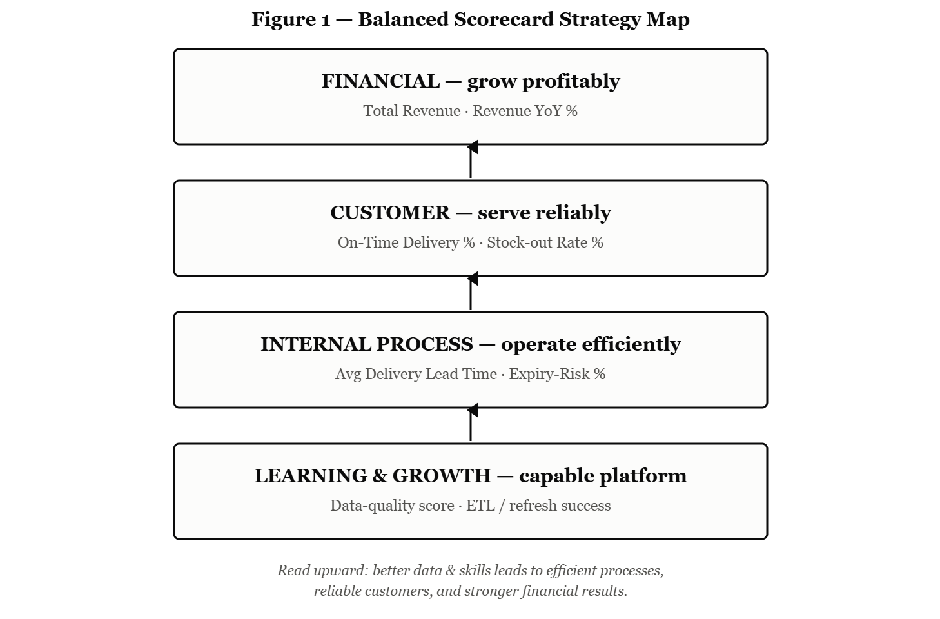
Figure 1 — Balanced Scorecard strategy map (four perspectives, arrows indicating bottom-up cause-and-effect).

3.2 System Architecture
The solution is built as a layered architecture, in which data flows in a single direction through a set of layers from the original systems to the dashboards [4] This layered approach gives separation between the jobs and makes the system easy to understand, maintain and scale. The whole architecture is presented in figure 2 and every layer is explained below.

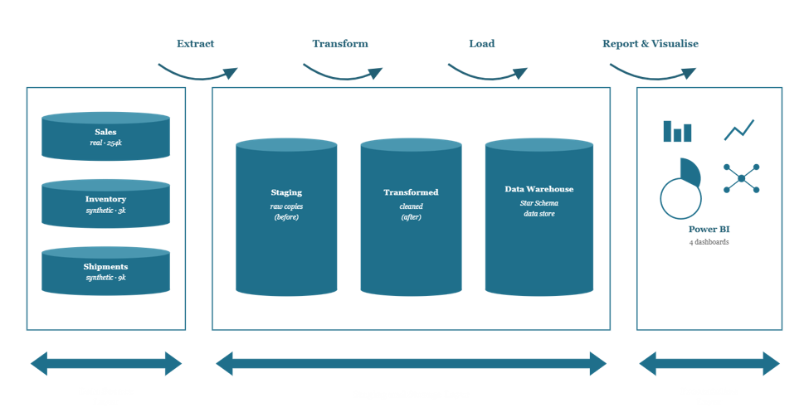Figure 2 — MediFlow BI System Architecture

1. Data Source Layer (the data capture points). This is where the data comes from. In a real business, MediFlow’s data would be captured automatically by its day-to-day operational systems: the sales system would log each distributor transaction, the warehouse and shipping system would record every dispatched delivery, and the inventory system would track stock levels, batches, and expiry dates. For this project these three capture points are represented by the sales, shipments and inventory datasets.
2. Staging Layer. The unaltered raw data from all three sources is then loaded into staging tables in a PostgreSQL database. This provides a safe landing spot for the messy source data before any cleaning is applied.
3. Transformation Layer. This is where the data is cleaned and integrated using SQL – removing duplicates, correcting dates and formats, standardising text, and applying business rules such as flagging late deliveries or at-risk stock. This is the ‘Transform’ stage which turns raw data into consistent information ready for analysis..
4. Data Warehouse Layer. The cleaned data is stored in a central data warehouse in a star schema of fact and dimension tables. This warehouse is the one place that all analysis is derived from [5].

5. Presentation Layer. Finally, Microsoft Power BI connects to the warehouse and delivers the analytics – four dashboards and a Balanced Scorecard
Analytics requirements. Each part of the architecture supports specific analytical needs. The warehouse must support historical analysis by time, product, geography, distributor, and customer. The presentation layer should provide executive summary KPIs, detailed inventory health, delivery performance and demand reports with the ability to filter and drill down (e.g. by year, distributor or product class) and forward looking demand forecasting. These requirements affected the design of the warehouse and the design of the dashboards.

.
Integrating the customer in the process. MediFlow doesn’t sell directly to the patients, but the customer is built in to the platform. Every sale is captured along with the hospital or pharmacy that received the product and the distributor that sold it. This means customer demand flows into the system as real orders, allowing the platform to analyse which channels and customers are buying what, alongside inventory and delivery performance. The platform’s monitoring also protects the customer: on-time delivery is measured against expected service levels and the stock-out and expiry indicators exist to ensure customers are never out of supply. The platform is therefore designed around the customer and the data model and decisions it enables.

3.3 Operations and Benefits

The platform is used in common use as a simple repeating cycle as shown in Figure 3. The data from the three source systems is loaded into the PostgreSQL warehouse, and is refreshed on a regular schedule, so the dashboards always show up-to-date information. Different people use different parts of it: Managers check the Executive dashboard for a quick overview, while operations staff use the Inventory, Supply & Delivery and Demand dashboards for their daily work. Each dashboard is designed to support a real decision – when to reorder stock, which distributors are late for their deliveries, which stock is close to expiry and how much demand to plan for. And, because the dashboards are interactive, users can filter and explore the data themselves, rather than waiting for a report to be generated.

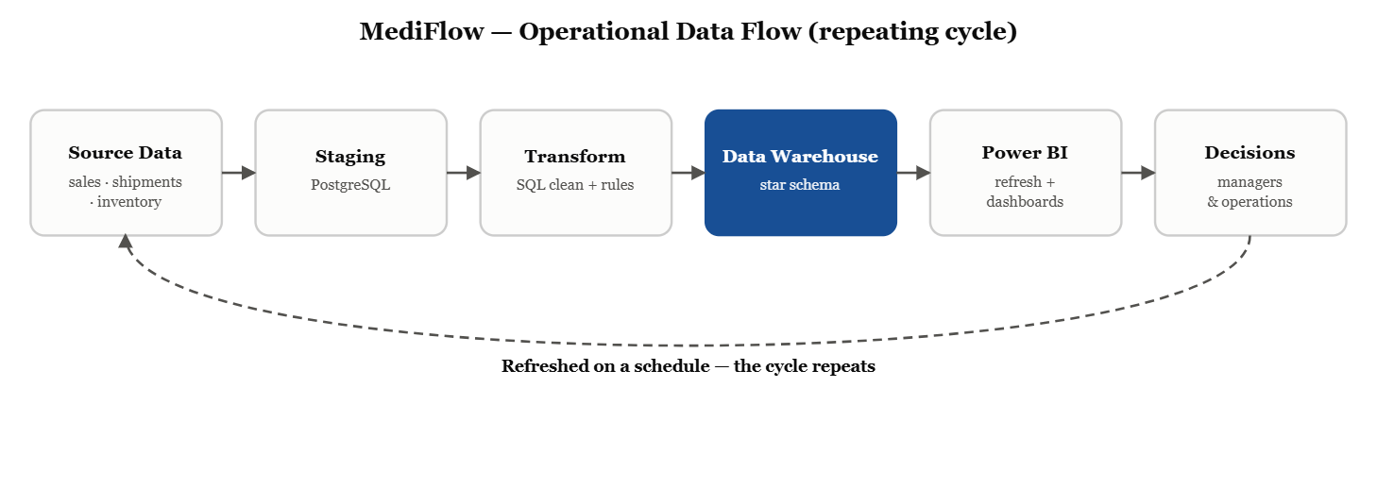
Figure 3 — MediFlow operational data flow (the repeating cycle from source data to decisions)
The benefits are practical and directly relate to the goals of MediFlow. The platform also helps to prevent stock-outs and lost sales by alerting when stock is running low, and reduces waste by highlighting products approaching expiry before they are thrown away. It’s a way to make deliveries more reliable by tracking on-time performance and flagging those distributor routes that are lagging. It helps in planning by providing demand patterns and predictive information about future demand. Most importantly, it is a clean, consolidated source of data so that managers can make decisions based on real evidence and not guesswork.

Finally, the entire solution is built using free, low-cost tools – Python, PostgreSQL and Power BI. This makes it cheap to run, quick to deploy and able to scale as the company’s data scales, which is a good fit for a business operating on thin margins where keeping costs down really matters.

Section 4: Implementation

4.1 Solution Specification
This section describes the actual construction of the platform that we designed in Section 3. It includes the tools we used, the data source, the warehouse construction, the data loading and cleaning, and what the final dashboards displayed. Each figure in this section is the result of executing the actual pipeline on the three data files.

- Python (using the pandas library) is utilized to create artificial inventory and shipment datasets from the actual product catalog, allowing them to be integrated with the sales data.
- The database used to stage the raw data and store the cleaned data warehouse is PostgreSQL with pgAdmin. SQL was used to write every ETL transformation.
- Microsoft Power BI Desktop, a presentation tool that connects to the warehouse, builds the data model and DAX measurements, and generates the four dashboards and Balanced Scorecard.

Design Component | Tool
Synthetic data generation | Python (with pandas library)
Staging & data warehouse (database) | PostgreSQL with pgAdmin
ETL / transformation | SQL (run in PostgreSQL)
Presentation layer (data model, DAX, dashboards & scorecard) | Microsoft Power BI Desktop

4.2 Data Sources
The three data sets, sales, shipments, and inventory, described in Section 2 were used in the implementation. As stated there, the shipment and inventory datasets are artificial, created in Python from the same real product catalogue in order to interface with the sales data; however, the sales dataset is real (a publicly accessible Kaggle dataset utilized in its authentic context). All of the business conclusions in this report are derived from the sales dataset alone, which has 254,082 records—much more than the required 5,000 records.

4.3 Data Model

4.3.1 Entity Relationship Diagram
The entity relationship diagram in Figure 4 illustrates the star (constellation) schema used by the data warehouse. A primary key that uniquely identifies each dimension table's rows is carried by each fact table as a foreign key that connects to the dimensions. Each link is one-to-many, meaning that numerous fact rows are connected to a single dimension row. This enables numerous transactions, including sales, shipments, and inventory, to be described by a single product, date, or place.
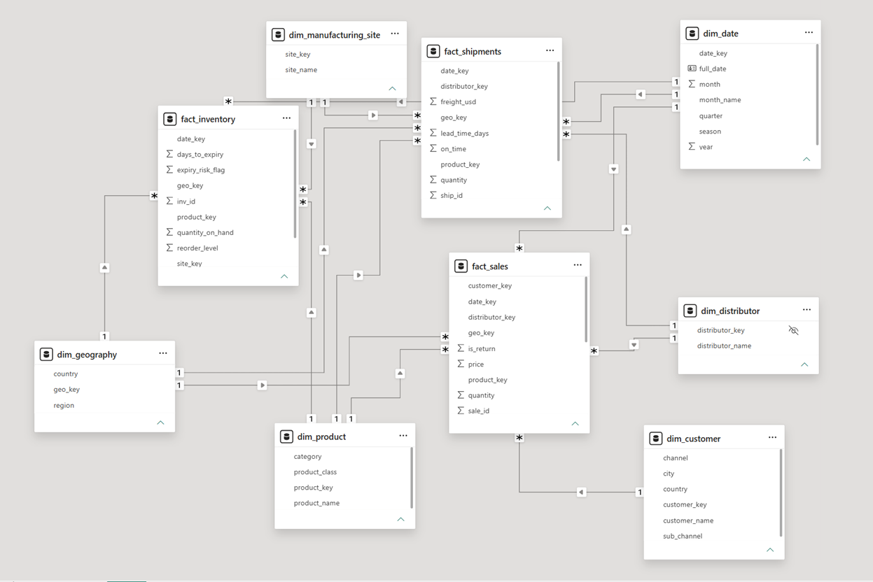
Figure 4 — Data Model of MediFlow from Power BI (Entity Relationship Diagram)

4.3.2 Schema Description
The dimensional modeling (star schema) approach is used in the warehouse [4]. Instead of combining unrelated measures into a single table, the design employs three fact tables that share common dimension tables because the company has three different processes: selling, delivering, and holding products. Demand, distribution, and inventory can all be examined using the same time, product, and location lenses thanks to its shared-dimension approach.
Fact tables hold the measurements and the keys that link to the dimensions:
- fact_sales — one row per sales line (254,078 rows)
- fact_shipments — one row per shipment (9,015 rows)
- fact_inventory — one row per stock snapshot (3,045 rows)

Tables | Information
fact_sales | Records one row per sales line — the source of demand and revenue.  PK sale_id; links to date, product, geography, customer and distributor.  Contains quantity, price, sales value and a return flag.
fact_shipments | Records one row per shipment — the source of distribution performance.  PK ship_id; links to date, product, geography, distributor and manufacturing site.  Contains quantity, freight cost, on-time flag and lead-time days.
fact_inventory | Records one row per stock snapshot — the source of inventory health.  PK inv_id; links to date, product, geography and manufacturing site.  Contains quantity on hand, reorder level, days to expiry and an expiry-risk flag.

Dimension tables hold the descriptive detail:
- dim_date (a 2017–2020 calendar),
- dim_product (product, class and category),
- dim_geography (country and region)
- dim_customer (hospital/pharmacy, channel and sub-channel)
- dim_distributor (the 29 distributors)
- dim_manufacturing_site (the five plants)

Tables | Information
dim_date | - Holds calendar information for analysing the business over time.  - PK date_key identifies each date.  - Contains the full date, month, month name, quarter, season and year.
dim_product | - Holds product information for product-level analysis.  - PK product_key identifies each product.  - Contains the product name, class, and category.
dim_geography | - Holds location information for analysing the business by market.  - PK geo_key identifies each location.  - Contains the country and region.
dim_customer | - Holds information about the hospitals and pharmacies products are sold to.  - PK customer_key identifies each customer.  - Contains the customer name, channel, sub-channel, city and country.
dim_distributor | - Holds information about the distribution partners MediFlow sells through.  - PK distributor_key identifies each distributor.  - Contains the distributor name.
dim_manufacturing_site | - Holds information about the plants where products are made.  - PK site_key identifies each site.  - Contains the site name.

All three fact tables share the conforming dimensions of date, product, and geography. Because they are two distinct parties at various stages of the chain—the distributor is the wholesale partner MediFlow sells through, and the customer is the hospital or pharmacy the product is sold to—the customer and distributor dimensions are intentionally kept apart. Since a distributor is never a customer in and of itself, keeping them apart allows for two separate methods of analyzing the business: distributor performance and customer behavior.

4.4 Extract Transformation Load

In PostgreSQL, all ETL work is done in SQL. Before being placed into the warehouse, the raw files are staged as is, cleaned, and transformed using SQL. Because everything is kept in SQL, a single script can be used to reconstruct the complete warehouse from the raw data.

4.4.1 Extraction and Staging
Each CSV is loaded into a relevant staging table (stg_sales, stg_shipments, stg_inventory) without modification using pgAdmin's import. The untidy raw data loads without being rejected since each column is stored as text, and all cleaning is done on purpose in the subsequent phase.

4.4.2 Transformation
The clean star constellation schema is created during the transformation step from the raw, text-only staging tables. The entire warehouse can be rebuilt from the raw files in a single run because everything is done in SQL. The rules used here are divided into three categories: business rules (calculating returns, on-time delivery, stock-out risk, and expiry risk), integration rules (connecting the three sources on shared keys), and cleaning rules (correcting sloppy text and missing values). There are four steps involved in the work.

1. Data Cleaning and Standardization
The company wants to make sure that everything is written the way. So they organize the data first. They use TRIM to get rid of spaces. Then they use INITCAP to make sure the capital letters are correct. For example "WARSAW PLANT" "warsaw plant" and "Warsaw Plant" all become the thing. They also use DISTINCT to get rid of duplicates.. If there are any missing values or "N/A" values they change them to NULL so they do not affect the totals later on.
For instance the list of manufacturing sites is cleaned up all once. They trim the list fix the capital letters and get rid of duplicates, in one step.
SQL
INSERT INTO dim_manufacturing_site (site_name)
SELECT DISTINCT INITCAP(TRIM(manufacturing_site))
FROM (SELECT manufacturing_site FROM stg_shipments
UNION SELECT manufacturing_site FROM stg_inventory) s
WHERE TRIM(manufacturing_site) <> '' AND manufacturing_site IS NOT NULL;
and the product class is cleaned into a tidy category, fixing the misspelling Antipiretics to Antipyretics and grouping Mood Stabilizers to CNS / Mood:
SQL
INSERT INTO dim_product (product_name, product_class, category)
SELECT DISTINCT TRIM(product_name), TRIM(product_class),
CASE TRIM(product_class)
WHEN 'Antipiretics' THEN 'Antipyretics'
WHEN 'Mood Stabilizers' THEN 'CNS / Mood'
ELSE TRIM(product_class) END
FROM stg_sales WHERE product_name IS NOT NULL;

2. Data Integration and Table Joins
Next, using shared dimensions, the three sources—sales, shipments, and inventory—are combined into a model. Dim_geography, for example, is built from a UNION of the nation columns in all three files because some dimensions are created from sources so that a single clean list is used by every fact. The raw text is then replaced with the dimensions key when each fact is connected to the dimensions. The sales fact shows the pattern; the row is linked to five dimensions at the same time, and the separate month and year columns are put together into a real date.
SQL
INSERT INTO fact_sales (date_key, product_key, geo_key, customer_key, distributor_key, quantity, price, sales, is_return)
SELECT dd.date_key, dp.product_key, dg.geo_key, dc.customer_key, ddist.distributor_key,
s.quantity::numeric(14,2), s.price::numeric(12,2), s.sales::numeric(16,2),
CASE WHEN s.sales::numeric < 0 THEN 1 ELSE 0 END
FROM (SELECT DISTINCT * FROM stg_sales) s
JOIN dim_date dd ON dd.full_date = TO_DATE(s.year||'-'||s.month||'-01','YYYY-Month-DD')
JOIN dim_product dp ON dp.product_name = TRIM(s.product_name) AND dp.product_class = TRIM(s.product_class)
JOIN dim_geography dg ON dg.country = TRIM(s.country)
JOIN dim_customer dc ON dc.customer_name = TRIM(s.customer_name)
JOIN dim_distributor ddist ON ddist.distributor_name = TRIM(s.distributor);
Sales, distribution, inventory, and product and geographic dimensions may all be examined side by side because all three facts have the same date. This is where integration truly takes place.

3. Business Rules and Derived Attributes
Some of the most helpful columns are computed here because they are absent from the raw data. When a sale's value is negative, it is marked as a return. We calculate the time it took and if each order arrived on schedule for shipments:
SQL
CASE WHEN TO_DATE(actual_delivery_date,'YYYY-MM-DD')
<= TO_DATE(scheduled_delivery_date,'YYYY-MM-DD') THEN 1 ELSE 0 END AS on_time,
(TO_DATE(actual_delivery_date,'YYYY-MM-DD') - TO_DATE(order_date,'YYYY-MM-DD')) AS lead_time_days
For inventory, we work out days-to-expiry, an expiry-risk flag for stock inside a 90-day window, and a combined stock-out risk. That stock-out rule is a real business rule: a line counts as at risk if it's flagged as a stock-out or if stock has dropped to or below its reorder level.
SQL
CASE WHEN LOWER(TRIM(stockout_flag)) IN ('yes','true','1')
OR (quantity_on_hand <= reorder_level) THEN 1 ELSE 0 END AS stockout_risk,
(TO_DATE(expiry_date,'YYYY-MM-DD') - DATE '2020-12-31') AS days_to_expiry

4. Data Segmentation and Output Preparation
The data is now ready for analysis after it is shaped into its warehouse format. Two checks are performed to make sure the data is clean. The first check uses SELECT DISTINCT * to remove copies of sales rows (254,082 becomes 254,078). The second check removes shipments that have a quantity of zero or negative numbers (9,055 becomes 9,015). The data is then split into fact tables and dimension tables. The fact tables hold the numbers and measurements. The dimension tables hold the descriptions and details.
SQL
WHERE sh.quantity_shipped::int > 0; -- removes 40 zero/negative rows
The dashboards can slice the data without additional computation thanks to the pre-made groupings (season, quarter, region, category, expiry-risk), and returns are retained but labeled independently.

4.4.3 Loading
There are two steps involved in loading. First, to ensure that each fact row finds a corresponding dimension key, the cleaned data is first imported into the PostgreSQL warehouse in a predetermined order: the six dimensions first, followed by the three fact tables.
Second, the warehouse is then imported into Power BI. With the help of the PostgreSQL connector, Power BI Desktop connects to the mediflow_dw database and extracts three fact tables and six dimensions. Then the Power BI Model (as shown in Figure 4) gets designed based on the star schema relationships, which become the base for all the reports and dashboards. After that, refreshing the report only requires the latest data from the warehouse.

4.4.4 Orchestration
A SQL build script run in pgAdmin takes charge of everything for the ETL process. The SQL build script avoids using a scheduling program to maintain the proper order since the SQL script does this by creating and populating the staging tables, dimensions, fact, and checking tables. Therefore, each process runs when the data required is ready. Furthermore, the whole warehouse can be built from the raw files at any time in an efficient manner since all processes are in a single SQL script that first drops and rebuilds the tables. At the end of this sequence is Power BI.

4.4.5 Central BI Storage and Final Architecture
The mediflow_dw data warehouse built in PostgreSQL based on the star constellation model works as the main BI repository. This data warehouse utilizes three fact tables (fact_sales, fact_shipments, and fact_inventory) which share the identical set of dimensions (dim_date, dim_product, dim_geography, dim_customer, dim_distributor, and dim_manufacturing_site). Even though all facts include measurements and keys linking to those dimensions, all dimensions include descriptive attributes with their own surrogate keys. The selling process, shipment process, and inventory management can all be analyzed through the same time, product, and geography perspectives due to the shared-dimensions approach. It is the only store that connects to the Power BI presentation layer, and it resides in the architecture of the entire system (Figure 2), and the schema of the data warehouse is shown in the ERD (Figure 4).

4.4.6 Presentation-layer shaping (Power BI)

The shaping of data for the presentation model was done simultaneously using Power BI's Power Query. This involved creating the same business rule columns that were necessary and also applying some presentation shaping of the data (renaming, data types, and validating the cleaned columns). Following that, DAX measures were created for the KPIs (Total Revenue, Revenue YoY%, On-Time Delivery%, Stock-out Rate%, Average Lead Time, Expiry-Risk%, and other measures) and links to the date dimension were established.
Since SQL and DAX operate in different stages, the calculations are done in DAX intentionally. SQL creates the stored and organized tables by cleaning and organizing the data once when it is being loaded into the warehouse. DAX, on the other hand, performs the analytical calculations dynamically when there is a need to create a report. That is, it calculates the measures each time, taking into consideration the filter context of the report, which involves the slicers, drill-downs, and cross-filters that have been applied by the user. For example, Total Revenue or On-Time Delivery % automatically gets calculated for the selected year, distributor, or product, without changing the stored data. Example measures:
DAX
Total Revenue = SUM ( fact_sales[sales] )

Revenue YoY % =
DIVIDE ( [Total Revenue] - CALCULATE ( [Total Revenue], DATEADD ( dim_date[full_date], -1, YEAR ) ),
CALCULATE ( [Total Revenue], DATEADD ( dim_date[full_date], -1, YEAR ) ))

On-Time Delivery % =
DIVIDE (
CALCULATE ( SUM ( fact_shipments[on_time] ), fact_shipments[status] = "Delivered" ),
CALCULATE ( COUNTROWS ( fact_shipments ), fact_shipments[status] = "Delivered" ))
Average Lead Time = AVERAGE ( fact_shipments[lead_time_days] )

Expiry-Risk % =
DIVIDE ( SUM ( fact_inventory[expiry_risk_flag] ), COUNTROWS ( fact_inventory ) )
These measures feed the dashboards described in Section 4.5.

Section 4.5 Visualization & Report
In this section, four interactive Power BI dashboards are presented for the Mediflow Pharma data warehouse. Every dashboard turns operation information into actionable business intelligence to inform executives, inventory, supply delivery and demand forecasting choices. This analysis is based on the final dashboards (only) that were developed in this project.

4.5.1 Executive Dashboard
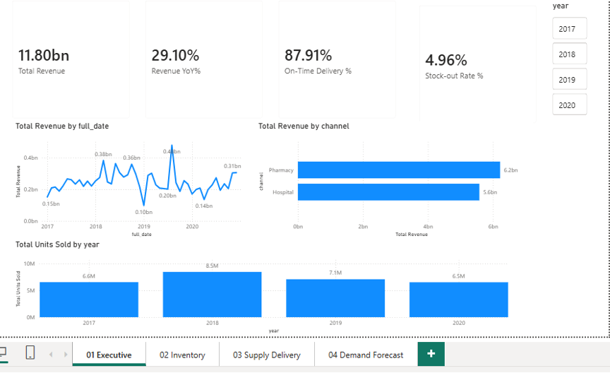

Figure 1. Executive Dashboard Overview
Dashboard Objective
Provide senior management with an integrated overview of financial and operational performance.

Dashboard Components
• KPI Cards: Total Revenue, Revenue YoY, On-Time Delivery, Stock-out Rate
• Revenue Trend
• Revenue by Channel
• Total Units Sold by Year
• Year slicer (2017–2020)

Key Findings
• Total Revenue: 11.80 bn
• Revenue YoY: 29.10%
• On-Time Delivery: 87.91%
• Stock-out Rate: 4.96%

Business Insight
Data shows positive revenue growth and reasonable levels of operational performance. The revenue growth rate of 29.10% and stock-out rate of 4.96% reflects that the company is still expanding its business with relatively controlled stock-out levels. Financial and operational KPIs are combined to provide the executives with a comprehensive assessment of the organisation's performance beyond just revenue.
Decision Support
Provides support to executive KPI monitoring, annual review, channel comparison, strategic planning, and resource allocation.

4.5.2 Inventory Dashboard

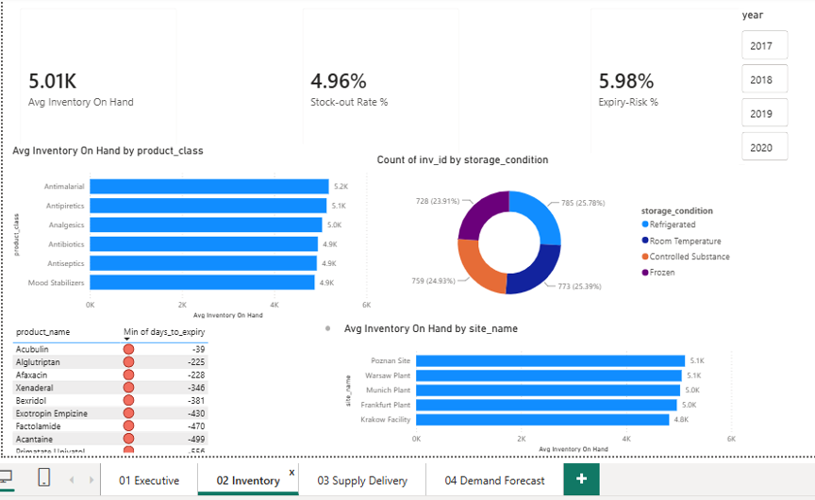

Figure 2. Inventory Dashboard
Dashboard Objective
Monitor inventory health, product availability and warehouse performance.

Dashboard Components
• KPI Cards: Average Inventory On Hand (5.01K), Stock-out Rate (4.96%), Expiry Risk (5.98%)
• Inventory by Product Class
• Storage Condition Distribution
• Inventory by Manufacturing Site
• Product Expiry Table

Key Findings
The average inventory was 5.01K, with an expiry risk of 5.98%. There were variations in the stocks available for various product categories and manufacturing locations. Product expiry monitoring identified expiring or imminent products.
Business Insight
The dashboard allows for proactive inventory management, balancing stock availability with the risk of expiration. Slow-moving stock can be identified and managers can monitor storage and optimise replenishment.
Decision Support
Facilitate inventory optimisation, warehouse planning, stock rotation and expiry-risk mitigation.

4.5.3 Supply Delivery Dashboard
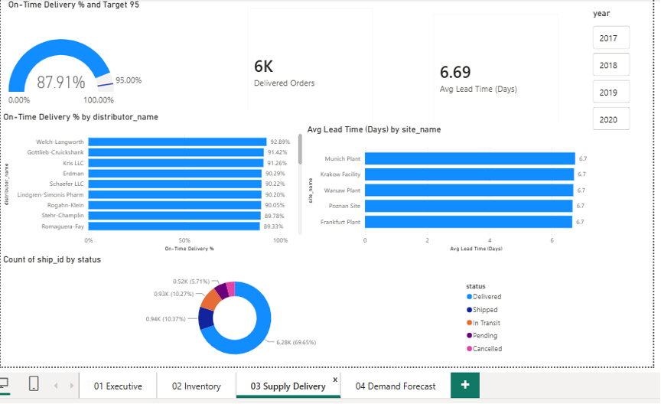

Figure 3. Supply Delivery Dashboard
Dashboard Objective
Evaluate logistics efficiency and delivery service performance.

Dashboard Components
• Gauge: On-Time Delivery vs 95% Target
• Delivered Orders (6K)
• Average Lead Time (6.69 Days)
• On-Time Delivery by Distributor
• Average Lead Time by Site
• Shipment Status Distribution
Key Findings
The Overall On-Time Delivery achieved 87.91% which falls below 95% target. About 6K deliveries were done within 6.69 days average lead time.
Business Insight
The gap between the current service level and the desired service level identifies opportunities for improving scheduling, transportation efficiency and distributor performance.
Decision Support
Facilitates logistic optimisation, supplier assessment, service level monitoring and operational improvement.

4.5.4 Demand Forecast Dashboard
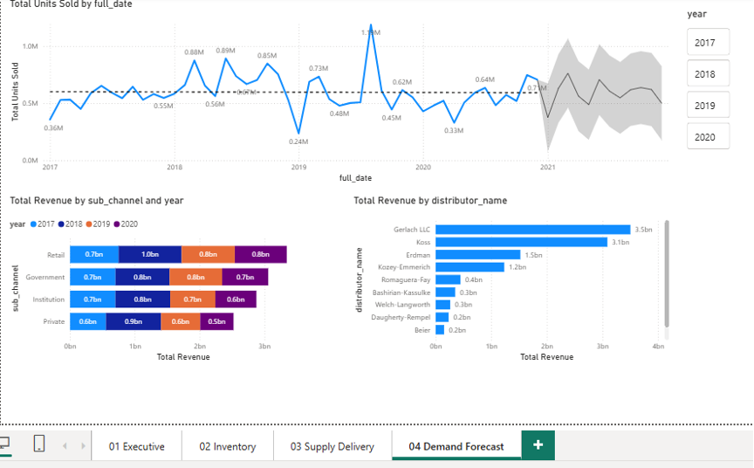
Figure 4. Demand Forecast Dashboard
Dashboard Objective
Analyse historical sales trends and estimate future demand.

Dashboard Components
• Historical Sales Trend
• Built-in Power BI Forecast
• Revenue by Sub-channel and Year
• Top Revenue by Distributor
• Year slicer

Key Findings
A 12-point ahead forecast spanning from 2017 till 2020 was developed for the time series based on the data collected over the period 2013 to 2020 with a confidence level of 95%.
Business Insight
Forecasting is science-based predicted demand for the future and is a statement of uncertainty. The trend can be used by managers to optimize their production, procurement and inventory planning.
Decision Support
Supports demand planning, production scheduling, procurement strategy and long-term business planning.

4.5.5 Overall Dashboard Findings
The four dashboards offer an integrated business Intelligence solution for Executive Performance, Inventory Management, Supply Delivery Forecasting and Demand Forecasting. In combination, they convert raw operational information into insights for decision making. The Executive Dashboard provides an overview of business performance, the Inventory Dashboard provides an inventory overview and expiry risk, the Supply Delivery Dashboard provides an overview of logistics performance against the 95% service target, and the Demand Forecast Dashboard provides a demand forecast based on a 12-point forecast and a 95% confidence interval. In summary, these dashboards highlight the power of Microsoft Power BI in aiding evidence-based decision making throughout the pharmaceutical value chain, while maintaining a balance between operational efficiency and strategic management.

Professional Note
This report purposefully restricts the conclusions to metrics that can be demonstrated in the final Power BI dashboard. No unsupported assumptions or fabricated analytical results have been made as is consistent with good academic and professional BI reporting practice.

4.5.6 Limitation
This project has a few limitations worth noting. Only the sales dataset represents actual operational data because two of the three data sources (shipments and inventory) are synthetic, created in Python from the real product catalogue, so only the sales dataset reflects genuine operational data. Additionally, because the data is restricted to 2017–2020, the dashboards display historical performance rather than a real-time feed, with stock-out and expiry calculated from a single snapshot. Lastly, features like scheduled cloud refresh, multi-user access, and demand forecasting are defined but not completely implemented because the platform operates locally on Power BI Desktop and a single PostgreSQL instance.

Section 5: Conclusion

The goal of this project was to solve a familiar problem in MediFlow: no one can see the complete picture because sales, shipments, and inventory data are kept in separate silos. The result is a functional BI platform that combines all three: staged, cleaned, and integrated via a SQL ETL process; stored in a central PostgreSQL warehouse constructed as a star constellation schema; and delivered through four Power BI dashboards and a Balanced Scorecard, with KPIs computed in DAX so the analytics react instantly to user filters.
Instead of just showing charts, the platform also provided insightful data: sales were concentrated in Germany and a few distributors, revenue peaked in 2018 before declining, on-time delivery stood at 87.9% against a 95% target, and some stock fell within the 90-day expiry window—all of which indicated a clear course of action. Its goal of replacing dispersed data with a single, dependable platform for evidence-based decisions is achieved since it was built with free, low-cost tools, is quick to implement, and scales to the cloud as the business expands.

Teamwork Contributions
As a team, we have been working collaboratively since our planning process where we chose the pharmaceutical industry, performed research about the organization, and read various sources both academically and online. In addition, we have selected suitable data sets, generated additional synthetic data sets using Python when the actual operational data could not be collected, and defined the scope, objectives, business requirements and strategy of our BI project. Following the direction of the project, assignments were assigned according to personal strengths and responsibilities. Swe Mya Phyu did the work of Sections 1-3.1 which cover the background, scope, objectives and business requirements of the project. On the other hand, Swe Swe Aung performed the work of Sections 3.2-4.4, whereas Shang Chun Wu covered Sections 4.5 and onwards.

References:
[1] International Federation of Pharmaceutical Manufacturers & Associations, "Understanding the Pharmaceutical Value Chain," IFPMA, 2023.Understanding-the-Pharmaceutical-Value-Chain

[2] S. George and S. Elrashid, "Inventory Management and Pharmaceutical Supply Chain Performance of Hospital Pharmacies in Bahrain: A Structural Equation Modeling Approach
[3] "Balanced Scorecard: History, Implementation, and Impact," Encyclopedia, vol. 5, no. 1, art. 39, 2025.

[4] AltexSoft, "Data Warehouse Architecture: Layers, Components, and Schemas.".
[5] IBM, "What Is a Data Warehouse?" IBM. [Online]. Available: Click or tap here to enter text.

